**Unit 1 - Lesson #3:** **Functions Transformations**

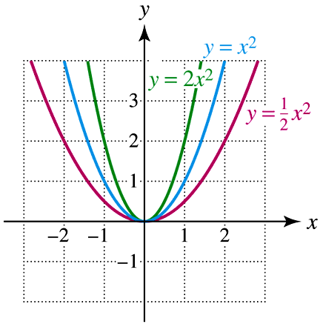

**Learning Targets:**

A parent function is the simplest form, in the set of functions that form a family. Each function in the family is a transformation of the parent function.

A new function is created when a parent function undergoes transformation and is given a new function rule (equation).

A vertical translation is when a constant is added or subtracted from the function.

A horizontal translation is when a constant is added or subtracted from the domain.

A vertical stretch or compression is when a scale factor is multiplied to the function.

A reflection is the x-axis is when the function is negated.

A reflection in the y-axis occurs if the domain is negated.

The order of doing the transformations is important.

Concept Summary: Transformations of $f(x)$

***Vertical Translations:*** ***Reflections:***

Up $k$ units: in $x$– axis:

Down $k$ units: in $y$– axis:

***Horizontal Translations:***  ***Vertical Stretches and Compressions:***

Right $k$ units: Vertical Stretch:

Left $k$ units: Vertical Compression:

So, if f(x) = x2, s(x) = x2 + 2, v(x) = (x + 3)2, and z(x) = (x – 4)2 – 1 …

How does s(x) look compared to f(x)?

How does v(x) look compared to f(x)?

How does z(x) look compared to f(x)?

Million Dollar Question: If applying more than one movement/translation, what order do these movements happen?

Order of Transformations:

**Example 1:** Combining Transformations

If $f\left(x\right)=\sqrt{x}$, sketch each of the following:

1) 2)

Equation: Equation:

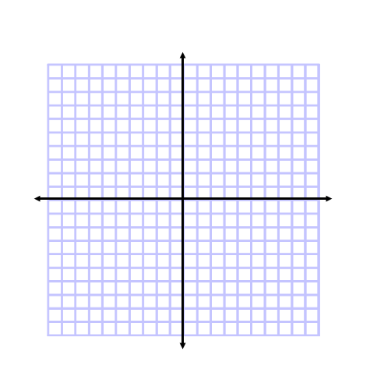 Transformations: Transformations:

3) $y=f\left(4-x\right)+1$

Equation:

 Transformations:

**Example 2:** Describe the transformations necessary to change $f\left(x\right)$ to $g\left(x\right)$, in the correct order.

a) $f\left(x\right)=\left|x\right|$ and $g\left(x\right)=-3\left|x-2\right|+4$

b) $f\left(x\right)=x^{3}$ and $g\left(x\right)=\frac{1}{2}{(x+7)}^{3}-9$

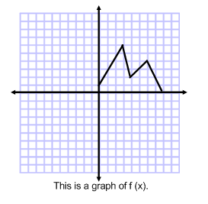**Example 3:**

Sketch $-f(x)$, $f(x+2)$, $f\left(x\right)-3$

**Example 4:** If $f\left(x\right)=x^{2}+3x+2$, write the equation for each of the following transformations:

$f(-x)$

$f(2x)$

$f(x-1)$

**Example 5:** If $f\left(x\right)=x$, write the equation of $g\left(x\right)$ that has a vertical stretch of factor 10, a reflection over the y-axis, a horizontal shift of 6 to the left, and a vertical shift down 3.

**Piecewise Functions**

$$f\left(x\right)=\left\{\begin{matrix}-x-8, -9≤x≤-3 \\ -x^{2}+4, -3≤x≤3 \\ x, 3<x≤7\end{matrix}\right.$$

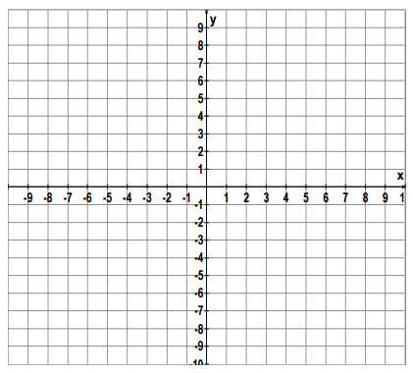

Is $f(x)$ a function? Explain.

**Homework 1-3:**

**\*\*\*ALGEBRA 2 REGENTS REVIEW\*\*\***

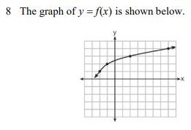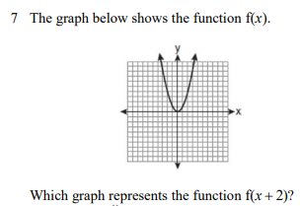Which graph represents f(x) – 2 ?

